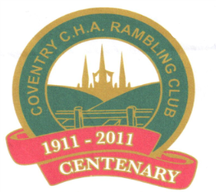 | Coventry CHA Rambling Club Newsletter June 2026

Coffee mornings update
Angela held a charity ploughman’s lunch on Saturday 13th June.
Everyone had a great time, as the weather was much better than it had been recently, if a little breezy now and again. We missed a few of our regular supporters due to illness and a change in the Saturday Walk schedule. However, we had a wonderful afternoon with live music, lots of chat and our resident auctioneer Terry! Thanks must go to all who supported in the kitchen, to all attendees and of course Angela’s hard work. All this added up to a very successful event. Later this month the club will be able to send £600 to Tools for Self-Reliance.
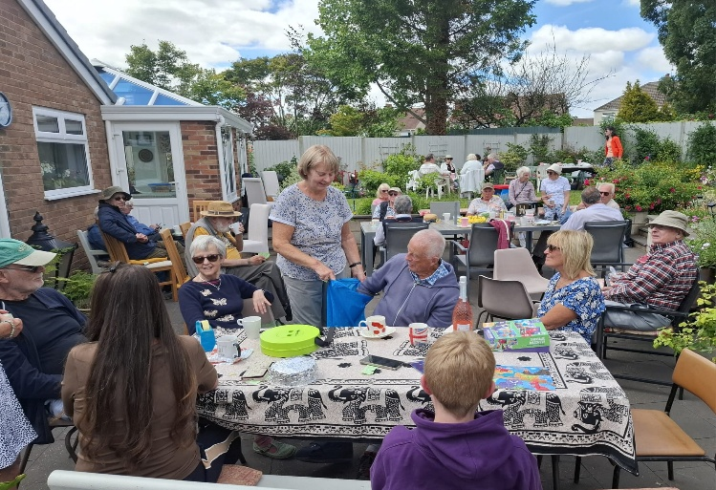
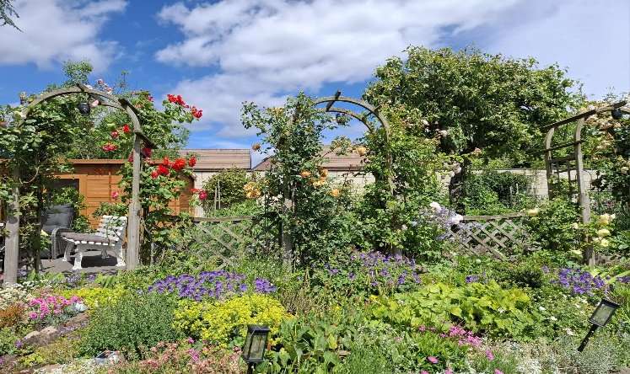
.

Sandra’s coffee morning is on Tuesday 21st July from 10am to 12 noon. Tea and cakes £5.
Pauline’s coffee morning is on Tuesday 12th August from 10am to 12 noon. Tea and cakes £5.

Congratulations to Aruna who was awarded a CBE (Commander of the Order of the British Empire). This was presented to her by King Charles earlier this year.
Aruna was Laboratory Manager at the University of Birmingham STEM (Science, Technology, Engineering and Mathematics) subjects for over 47 years.
Her family also had the opportunity to meet the Lord Lieutenant of West Midlands, John Crabtree, at a presentation of the medal with a further invitation to a garden party at Buckingham Palace and met Queen Camilla and King Charles.
Well done, Aruna — well deserved!
Aruna wrote a little paragraph of her thoughts at having received the CBE.
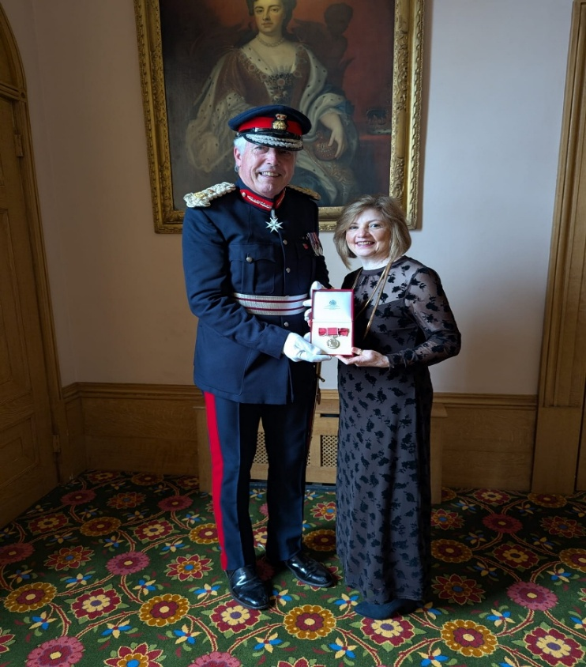
“A humbling recognition-a true honour that feels more meaningful because of the incredible people I've had the privilege to work alongside throughout my career. My career spans over 47 years, where I have learned and grown so much thanks to colleagues who have helped shape my journey, and not least the students, whose energy, curiosity, and resilience have made the experience profoundly rewarding. To receive this recognition feels like a shared celebration of all the people who've been part of that path, and reflects the strength, and values that surround me. I carry it with pride, and with gratitude to all of you.”

Charity/social events report 2026
Skittles Night, Brandon Social Club, Saturday 25th April 2026, 7pm – 11pm.
The skittles night went very well indeed. All tickets were sold and the fish and chip suppers were scrumptious!
Many thanks go to helpers and to all those who donated prizes for the raffle. Proceeds from this night will go to Breast Cancer Research.

Thursford trip. All tickets have now been sold for this event.

FUTURE EVENTS


Hook Norton Brewery Vintage Coach Trip, Tuesday 14th July 2026.
By popular request, places can now be booked for the repeat Vintage Coach Trip to Hook Norton Brewery. The cost of £30 per person includes the coach fare and the entrance fee to the museum with a guided tour of the brewery. This trip is open to members’ families and friends.

Dave’s Disco Dance Night, Eastern Green Social Club, Saturday 14th November 2026, 7pm-11pm.
After such a fantastic night last year, by popular demand we will be repeating Dave’s Disco Dance Night in November, but this time at the Eastern Green Social Club. Tickets will be £15 which will include a fish and chip supper.


Christmas Party, Eastern Green Social Club, Friday 11th December 2026, 12 noon-4pm.
Put the date in your diary for the club’s Christmas Party to be held at the Eastern Green Social Club. Once again there will be music, games, quizzes and entertainment. Tickets will be £15 which includes a buffet.

Terry Charity/Social Events Organiser

Sunday walks update

There will be a Sunday Walk every month for the next six months, providing there is enough interest.

The usual arrangements re. booking apply i.e. via club phone, 07 388 171 485
The cost is £20, and this will be collected on the coach.

Parking is available as before in Wickes car park. The £1 donation will also be collected on the coach.

All coaches will leave from outside the Salvation Army at 9am, returning to Coventry at around 6pm.
As previously, if you have booked to go on the coach and you do not attend, you will be expected to pay the cost.
Please support these coach trips if you want them to continue!

Reports
April 26th. “Chepstow”. This was a walk of approximately 5 miles led by Richard.
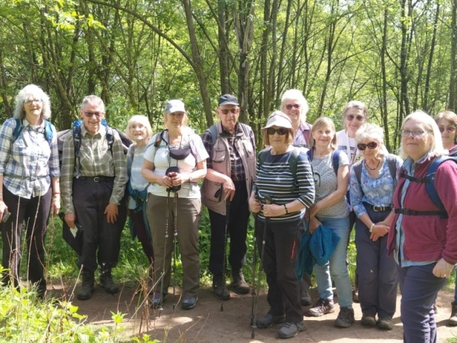
We started from Chepstow Castle car park. There was quite a steep incline to begin with past the castle, but the remainder of the walk along the Wye Valley was relatively flat except for the odd undulation. We were fortunate with a fine sunny day and we had good dry paths.

May 17th. “Towcester”. Again, led by Richard, the walk was approximately 5½ miles. Twenty-seven people took the coach to Towcester, 17 of us joined Richard and Dave’s walk from Towcester cemetery, and the remainder spent their time sampling the delights of Towcester. Again, the sun gods were shining down on us and the walkers had a very pleasant largely level walk around the Northamptonshire countryside.

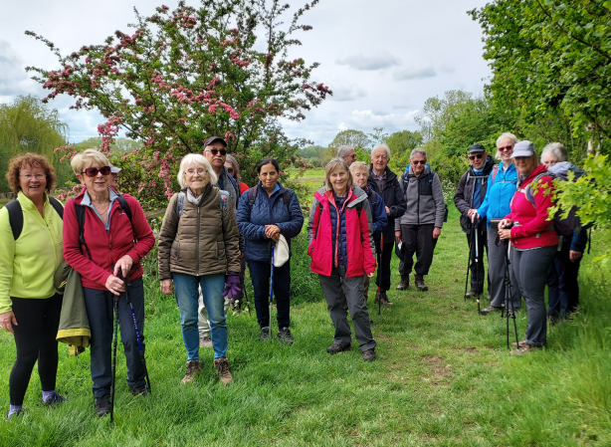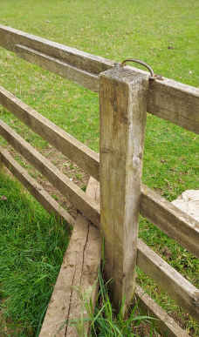
We noted several stiles with strategically placed handles to help you get over.

Just a special mention to thank Richard for the time he takes in producing a detailed itinerary and map for everyone. Much appreciated!

FUTURE SUNDAY WALKS

Sunday 21st June. Tewkesbury walk. Leader Geoff.

Sunday 19th July. Evesham walk. Leader Dave.

16th August – St Ives, Cambridge

20th September – Leek, Staffordshire

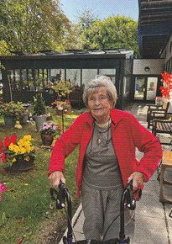
Pearl Richardson Obituary
Margaret Richardson, known as Pearl, died on 3rd March 2026 aged 94 years. She grew up in County Donegal, the northernmost county of the Republic of Ireland. She came to England, trained as a nurse and later became a sister at Coventry Gulson Road Hospital. She has a son Ian but sadly lost her husband John, who passed away unexpectedly. She joined the Coventry CHA Rambling Club in October 1988 and slowly recovered from her loss. Pearl often said that the club played a very important part in helping her with this loss. She became a club committee member and was elected President in 1999-2000. During her reign she organized two successful evenings; one to Tamworth Castle by candlelight with a meal in the town and the other to Walsall Illuminations.
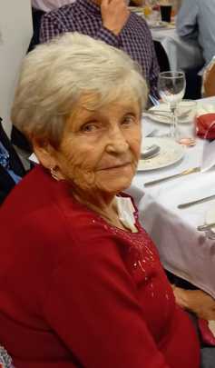
She made many friends, particularly Hazel Hancock and Kath Lenton. They became known as the “Golden Girls” after the American television sitcom. She walked with the club every Sunday, went on club holidays at home and abroad and attended all weekend breaks at Youth Hostels! and hotels. She always walked near the front of a ramble and at about 11 am would remind the leader about having a coffee break. Any club social event, such as Barn Dances, Parties, Quiz and Skittles Nights or dates for footpath clearance were in her diary. Outside club activities, she loved her holidays and happily joined Hazel who traveled the world.
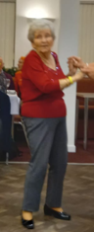
Her relaxation was a wee dram of whiskey and watching Strictly Come Dancing. Naturally she doted on her two granddaughters. Always very active and loving life, Pearl will be very much missed. She is remembered fondly by club members as a lovely positive determined person and a great asset to the club.
Richard.

